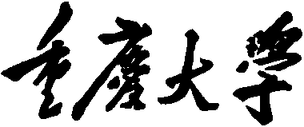


Personal Learning Portfolio

Course： English Academic Writing Teacher： Zhang Mei
Class： 001 Major： CS
Name： Student Number：
Class Time： 2024.02-2024.06
Grade：

Self | Teaching Assistant | Teacher
9

Comments：

Teacher (Signature)
Contents

Research Methodology
- My learning
- In class
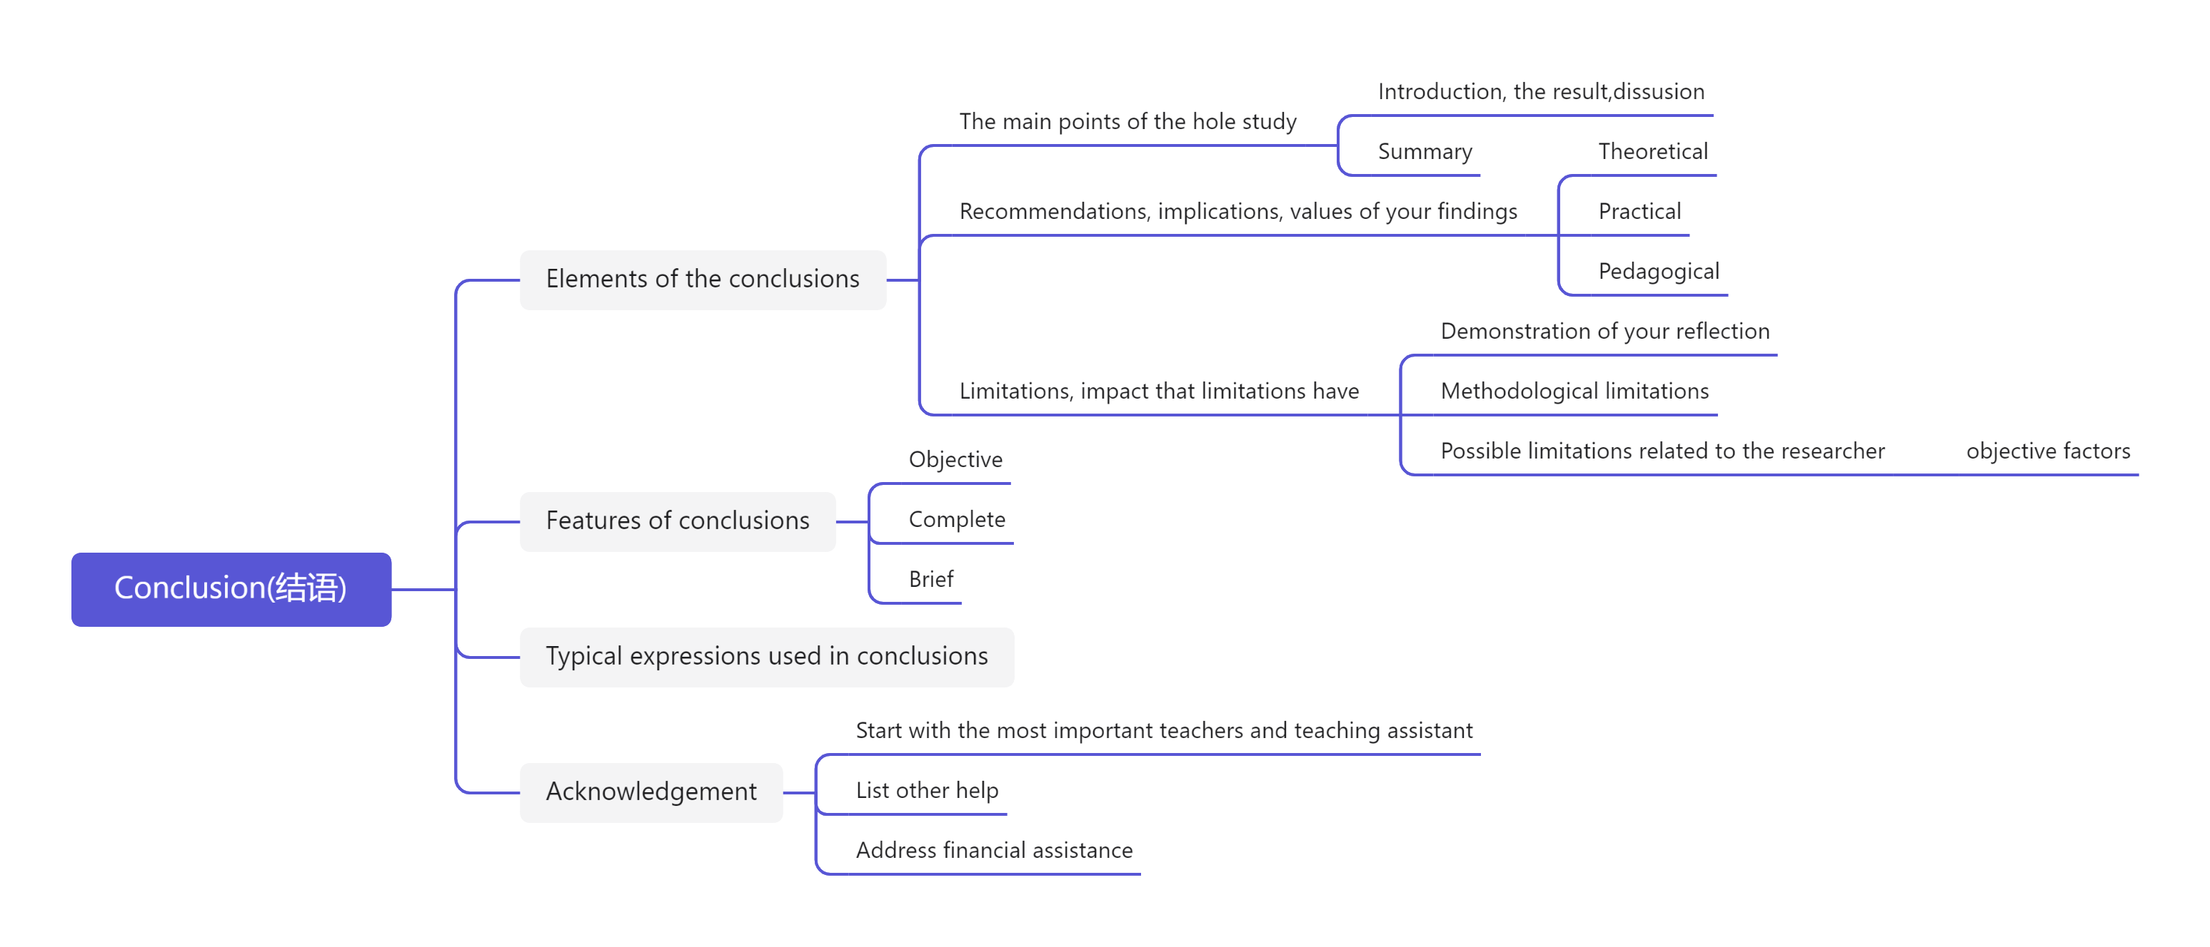

- Learning outcomes
1）In class
1) When writing the conclusion of my paper, I need to describe three parts: the main points of the hole study, recommendation, and limitations.
2) When writing the conclusion of my paper, I should pay attention to the objectivity, completeness, and conciseness of the language.
2) When writing my thesis gratitude, I need to first express the most important help I have received.
3. My behavior and attitude
1）Out of Class
1.1 Autonomous learning (Online + Offline)
1.1.1 Online (CET-6 online course)
1.1.2 Offline (memorize vocabulary and listen to CET-6 listening exercises)
1.2 Homework
I completed my English assignment promptly with a diligent and meticulous attitude, ensuring it was not procrastinated until the deadline.
1.3 Cooperative learning
2）In Class
2.1 Individual performance (Take notes promptly and attentively focus during class).
2.2 Cooperation (Actively participate in classroom discussions)

4．Improvement
In Class
During this week's class, I was taught how to craft the epilogue and acknowledgments of a paper, as well as gaining exposure to various commonly used terminology.

